Statement

Of

Frank Vehlen
Executive Vice President and COO
Heimann Systems Corp.
Pine Brook, New Jersey

Before

Subcommittee on Aviation
Committee on Transportation and Infrastructure
US House of Representatives
December 7th, 2001

Concerning

100% Checked baggage screening

Good morning Mr. Chairman and distinguished members of the subcommittee.

I am Frank Vehlen, Executive Vice President and Chief Operating Officer of Heimann Systems Corp. We thank you for the opportunity to participate in this hearing and discuss the challenges of 100% screening of all checked baggage in the United States.

Heimann Systems is the largest supplier of X-Ray security equipment in the world with over 17,000 units installed in 150 countries. 125 of those units are Automatic Explosives Detection Systems that are fully integrated in the baggage handling system. Several of those integrated systems are designed to screen 100% of all baggage of the airport.

We have engineering, manufacturing and technical services in the United States including operations in New Jersey, Tennessee and Nevada. Heimann Systems is a major supplier to the FAA and other federal agencies. More than 3,000 Heimann units are installed in the United States.

Mr. Chairman, please allow me to be very straightforward.

- We applaud the objective of 100% screening of checked bags. However, the goal to deploy only current certified Explosives Detection Systems to allow for 100% screening of all checked bags by December 2002 is simply not realistic.
- Furthermore deploying the present certified technology, which is all CT based, is extremely costly both in implementation and in operation.
- Also the logistics and space required are not there to effectively support such a solution.
- Prior to September 11th the goal of the FAA was to start the phasing in of 100% checked baggage screening by 2009 and complete it by 2014. This was a timeframe of 13 years. Now we want to achieve this goal in 13 months?
- The economic impact of implementing this goal correctly versus incorrectly could be enormous.

Let me explain why: The FAA, in the International Aviation Security Technology Symposium held last week in Atlantic City, stated that between 2,200 and 2,300 CT’s would be needed to accomplish 100% inspection of all checked bags in the US. The manufacturers current capacity - only two companies have a CT product that is FAA certified - does not allow for the manufacturing of over 2 thousand units in one year. Even if they were able to ramp up production, most airports will not be ready to receive the units by the 2002 deadline.

In addition, the cost of this endeavor is, to say the least, significant. At one million dollars per CT, this amounts to over 2 billion dollars in hardware that may be rendered obsolete before deployment is completed. This does not include the installation cost. Furthermore, the typical maintenance for a CT costs between $ 60,000 and $100,000 per year. This could amount to $200 million dollars in annual recurring costs. Add to that the personnel needed to operate the systems; at an average of three operators per CT this amounts to the staggering amount of more than 720 million dollars per year.

However for the moment let us forget these figures and look at other aspects related to the deployment of CT’s in the lobby of airports. The footprint needed for a CT including the space for operators, passengers and queuing, is at least 20’ by 30’ or 600 sq. ft. per CT. An airport such as O’Hare in Chicago would need over 100 CT’s. This represents lobby space the equivalent of approximately 1.25 football fields.

Quite clearly, the currently discussed solution of only deploying today’s certified systems, with dramatic throughput limitations, will require a substantial number of systems and a significant increase in security personnel for the management of manual baggage handling and logistics, all at a dramatic cost to the tax payer.

In addition this solution will put further obligation on the traveling public to commit additional time for the security screening process. Is an additional hour added to already burdensome process acceptable? While we do not know the answer to this question, we are confident that any significant inconvenience to traveling public will hinder the opportunity for the Aviation Industry to fully recover and hopefully once again thrive.

What’s the alternative?

As seen in numerous airports worldwide, integrating fast security screening technology into the baggage handling systems of the airport, immediately allows
for the screening of all checked luggage, while decreasing the number of systems required, and simplifying overall logistical processes with no inconvenience to the traveling public.

More than 300 high throughput EDS systems are operating in airports around the world as integrated components of the baggage handling system. Most of these installations are designed to screen 100% of the checked baggage.

Mr. Chairman, I would like to invite members of committee to visit a fully integrated explosives detection solution.

What is the difference? Most of these units have been tested by the FAA and typically meet the FAA “advanced technology” detection level.

Recognizing that detection can be improved, 3 years ago we started the development of the next generation of high throughput EDS, called EdtS, that combines the detection criteria set by the FAA with the operational requirements of the airports. The design goal was full integration into the existing conveyor systems of airports, throughput of 1,500 bags per hour and meeting or exceeding all FAA requirements, at significant lower cost than the current CT’s.

I am pleased to hand you Mr. Chairman a picture of EdtS.

EDtS takes proven technology and applies it in an innovative manner to accomplish the desired result. It combines the dual energy technology of the current high speed EDS units with the volumetric density analysis a CT uses to detect explosives. We plan to deliver this new and improved system to the FAA in May of 2002 to commence certification testing and would welcome any and all ideas and suggestions on how to accelerate this process.

What should be done immediately to reach 100% screening?

We believe it is a multi solution approach that will improve security, is operationally practical, will meditate risk and avoid wasteful spending.

- Use the current deployed certified EDS in conjunction with CAPS to its maximum throughput and capacity.
- Analyze the airports to determine which airport baggage handling systems can be modified for integrating EDS equipment.
- Start the planning for integration of high speed EDS immediately and deploy available equipment, which will be certified in the near future.
- Deploy the current certified EDS technology in the lobbies of airports that will not be able to accommodate integrated solutions for the foreseeable future.
- Support final development and engineering steps for high speed EDS to meet certification ASAP.
- Deploy conventional X-Ray units in combination with Trace Detection at locations that are being prepared for integrated solutions. These units can be delivered by several manufactures and are the fastest solution to achieve 100% screening, possibly even achieving the December 2002 deadline. These units can be used in other applications once the integrated solutions are installed.
- Accelerate the development of complementary technologies like X-Ray diffraction to be implemented for automatic false alarm resolution.

“Activity does not mean progress”. Let us be smart and approach the challenge of checked baggage screening in a way that ensures a practical and manageable solution for the airports, the air carriers, the traveling public and the federal government. Let us put a system in place that addresses the current security needs and at the same time allows the insertion of technology as it evolves.
Last but not least let us put a technology in place that is much more cost effective for the taxpayer.

Mr. Chairman, this completes my statement and I will be pleased to address your questions.

Appendix

EDtS – 2. Generation High Speed Explosives Detection Systems
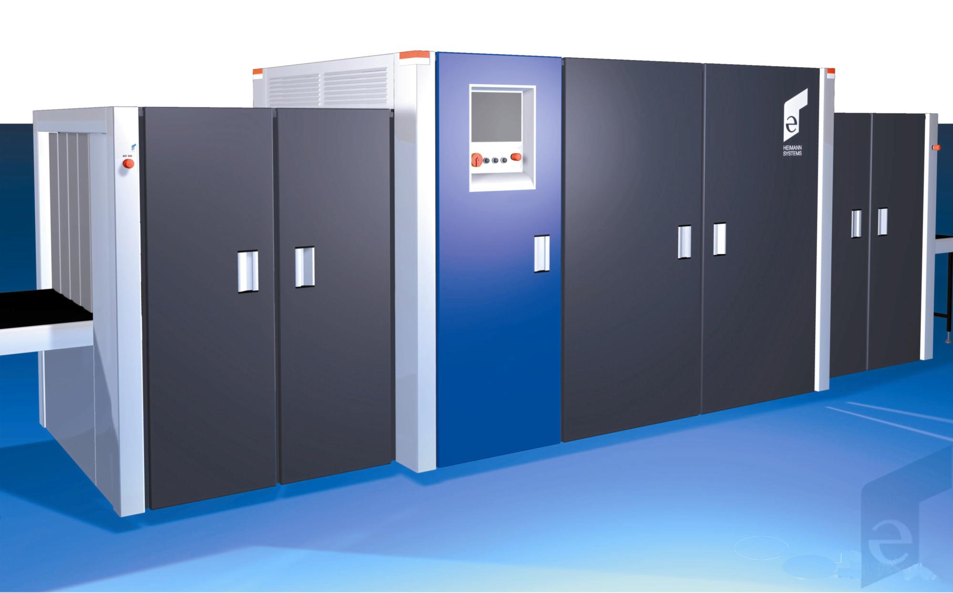

- High detection rate and minimized error alarm rate

- 3-D image evaluation CT like

- Detection of bulk and sheet explosives

- Integrated throughput of 1,500 baggage items per hour

- Easy replacement of existing equipment

- Designed to achieve FAA certification

Integrated Multi Level Solution
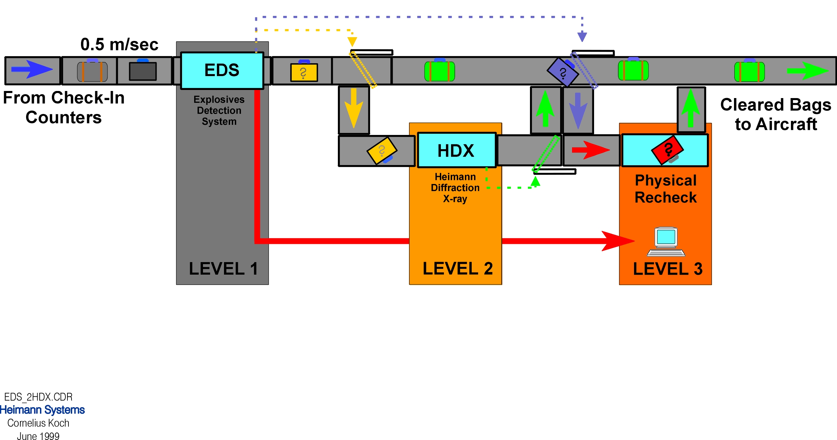

HiScan 6040i Proline
