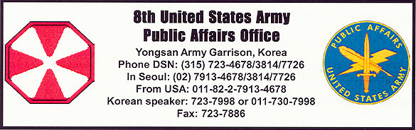
Press Release 15-20030523 May 15, 2003

501st Military Intelligence Brigade displays capabilities
By Sgt. Russell C. Bassett

CAMP HUMPHREYS, Republic of Korea – The 501st Military Intelligence Brigade showcased the strength of the ROK/U.S. Intelligence community alliance at their Capabilities Display Wednesday and Thursday.
The display was designed to provide U.S. and Republic of Korea intelligence professionals with a better understanding of the brigade’s equipment, systems and missions, and to enhance the brigade’s partnership with their ROK Intelligence counterparts, said the release.
The brigade allowed intelligence professionals from all Eighth Army units including the 2nd Infantry Division into their base of operations on Wednesday. Republic of Korea Intelligence professionals, including the students of the ROK Intelligence Academy, members of the Korean Defense Intelligence Agency and members of the Korean Security Agency attended the demonstration on Thursday.
The brigade opened each day by showing all intelligence personnel attending the event on the missions of the intelligence gathering airplanes, the Counter Intelligence “Go Team,” and the Deployable Intelligence Support Element (DISE).
“The 501st mission is to provide combat information and multi-disciplined intelligence to joint and combined warfighters,” said Col. Mary Legere, the 501st’s commander. “On a daily basis we collect, analyze, synthesize and produce intelligence regarding the North Korean People’s Army.”
Maj. Fern Sumpter, S-3 of one of the 501st’s subordinate units, the 532nd MI Battalion, and the officer in charge of the DISE, said the brigade’s soldiers are what enable the unit to successfully accomplish its missions.
“If you take a look around at our soldiers you will notice the most senior soldier sitting at a piece of equipment is a specialist,” she said. “They are the experts in the field, and, every time we take the DISE out, the first thing the commander notices is how great our soldiers are.”
Spc. Angelica Capuchino, electronic warfare intercept repairer, 3rd MI Battalion, who helps ensure that the equipment of the intelligence gathering airplanes is working properly, said she believes in the importance of her work.
“I like MI because we actually work – we have things to do everyday,” she said. “Mission is top priority here. These planes are running actual missions and we send them out every day.”
Soldiers of the 501st have a real-world mission so they must remain constantly vigilant; however, according to Legere, this does not slow the brigade’s training objectives.
“On a nightly and daily basis we can never take our eyes off the North, so our mission occurs 24-7 and our training occurs simultaneously with that,” she said. “We train in this brigade extremely hard.”
Legere went on to say that the reason the 501st trains so often is because it is constantly working with the ROK Army.
“The 501st MI Brigade has been in this country for over 50 years, since the inception of the ROK Army Intelligence Corps,” said the commander, who has had three tours in Korea. “In eight months this brigade has exercised 21 times with our ROK counterparts.”
On Thursday, over 200 students from the ROK Intelligence Academy were on site to learn from the brigade’s soldiers, and Legere stressed the importance of the ROK/U.S. alliance in intelligence gathering on the peninsula.
“One of the most unique features about the MI Brigade is that our structure is actually combined,” she said. “In each of our battalions there are ROK soldiers assigned and the information is shared on a daily basis because we are all part of the same organization. By having ROK soldiers in our formation, that happens very smoothly and very routinely.”

