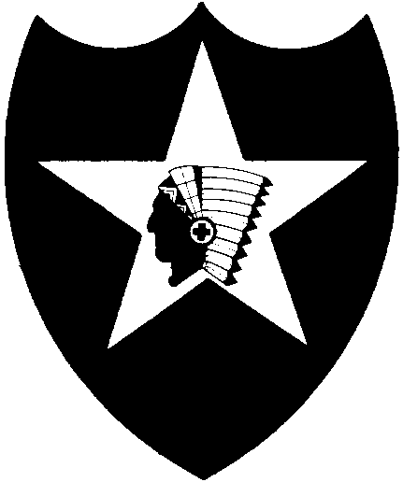

PRESS RELEASE
2nd Infantry Division

Public Affairs Office

Commercial Phone: (031) 870-8877
Fax: (031) 870-8888
E-mail: makab@usfk.korea.army.mil

May 9, 2003
2nd Infantry Division Public Affairs Office

ROK Prime Minister visits the Second Infantry Division

CAMP RED CLOUD, Republic of Korea- The Prime Minister of the Republic of Korea, His Excellency Goh Kun made an historic visit to the US Army’s Second Infantry Division today.
Prime Minister Goh was accompanied by His Excellency Cho, Young Kil, Minister of National Defense and Gen. Shin, Il Soon, Deputy Commander, Combined Forces Command. The official party was greeted by Gen. Leon LaPorte, Commander, United Nations Command, Combined Forces Command and United States Forces Korea and Maj. Gen. John R. Wood, Commanding General, 2d Infantry Division.
After an honor ceremony featuring a 19-gun salute and a brief meeting with Gen. LaPorte and Maj. Gen. Wood, Prime Minister Goh addressed a gathering of nearly 400 Second Infantry Division soldiers.
“I want to sincerely thank Gen. LaPorte, Maj. Gen. Wood and the soldiers who represent the invincible 2d Infantry Division,” said Goh. “I along with 47 million Korean people thank the soldiers who are serving at the front line, in defense of peace away from their homes.”
Prime Minister Goh focused his remarks on what he called the “Frontline Partnership” of the ROK-US Alliance. “Not only through past, present, but even in the future, the alliance between the Republic of Korea and the United States is very important in that it is the basis for deterring war on the Korean Peninsula,” he said. “The Korean people are very aware of the fact that the security alliance of the Republic of Korea and the United States is the core of the Korean Peninsula’s peace and security.”
This year marks the 50th anniversary of the ROK-US Alliance. “Friends in need are friends indeed and the United States has been Korea’s real friend, helping Korea out any time it was going through a difficult time, said Goh. “The United States freed Korea from Japanese colonization and also defended it from communist invasion.”
Goh also promised support from the government after commenting that the Good Neighbor Program begun by USFK as an exemplary program to enhance understanding and coalition strength.

-more-
“On behalf of the soldiers of the 2d Infantry Division, I want to thank Prime Minister Goh for the support he has provided,” said Maj. Gen. John R. Wood. “ Your visit today has opened a new chapter in the division’s history.”
Prime Minister Goh presented the soldiers of the 2d Infantry Division with a large screen digital television. “ I present this television so that the soldiers may watch the Republic of Korea and United States Alliance become enhanced,” said Goh.
Prime minister Goh’s visit to Camp Red Cloud marks the first time a Republic of Korea prime minister has visited the 2d Infantry Division.

-30-

