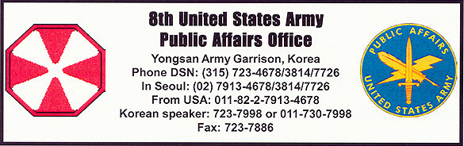
Press Release 13-20030521 May 21, 2003

Honor Guard showcases primary mission
By Sgt. Russell C. Bassett

CAMP BONIFAS, Republic of Korea – The United Nations Command Honor Guard Company is best known for its performance at ceremonies, but, as showcased in Tuesday’s Close Quarters Battle Exercise at the Joint Security Area, that is not its primary mission.
“Basically everyone knows the Honor Guard from ceremonial duties at Knight Field (in Yongsan), but what most people don’t realize is that our primary mission is actually the security of the combatant commander, his household, his place of duty and other key command and control facilities in Seoul,” said 1st Sgt. Lance Dyckman, the Honor Guard’s first sergeant.
To train for that mission, the Honor Guard Company conducts regular exercises and training events.
“We get involved with 2nd Infantry Division with its field exercises, we also do numerous marksmanship ranges, and proficiency ranges,” said Dyckman.
He compared the Honor Guard’s training to that of the Rangers or the FBI.
Wednesday, the Honor Guard conducted its quarterly Close Combat Battle Exercise at the Close Quarters Combat Range, or “shoot house,” at Camp Bonifas.
The shoot house is a building containing four rooms and two hallways in which a team of combatants “sweeps” through to “clear” the rooms. Four-man teams of Honor Guard soldiers conducted a dry fire and a blank fire, before using live runs to sweep the targets out of the shoot house.
“(The exercise) gave us the advantage of learning to shoot while moving and clearing out rooms because that is our main mission,” said Spc. Jerald Rutter, Honor Guard member. “If North Korea ever does come into Yongsan, it is our job to fight building to building.”
The Honor Guard’s commander, Cpt. Jackson Seims, was pleased with how the exercise was conducted.
“This was a chance for us to train-up new soldiers and sustain the ones that have been here for a while,” he said. “It is imperative for any soldier, especially Honor Guard soldiers, to be ready around the clock, all the time, and there is only one way to accomplish that – and it’s not from talking about it – it’s from training.”
And the UNC Honor Guard Co. does exactly that.
“At the end of the day, we are an infantry company, and we get to do a lot of infantry stuff on a regular basis,” said Dyckman. “Our guys put a lot of rounds down range.”
Seims said the Honor Guard is always looking for motivated soldiers who like to train. He also said the company has soldiers from just about every Military Occupational Specialty and is open to everyone.
Those interested in joining the Honor Guard are recommended to call 1st Sgt. Dyckman at (DSN) 725-6167 or e-mail him at dyckmanl@usfk.korea.army.mil.

